Paper-contribution intake pipeline
David, here is my best reconstruction. I read the board as a paper-contribution intake pipeline: a user contributes some bibliographic object — DOI, APA citation, abstract, PDF, or ZIP of PDFs — and the system normalizes it, checks whether the corpus already has it, retrieves missing metadata/PDF when lawful, classifies it, records provenance, and verifies the final record.

Best reading of the handwriting
Uncertain words are marked with [?].
- “Write [?] + success conditions + verification scripts”
- Contribute
  - user supplies:
    - APA citation
    - abstract → DOI
    - PDF
    - single PDF or multiple PDFs in ZIP
- Main metadata fields:
  - DOI
  - citation
  - abstract
  - PDF
  - provenance
  - meta type
  - topic
- Pipeline:
  - filter
  - duplicate check
  - “do we have it?” → check corpus / database
  - if missing or incomplete → need it → process
  - get abstract
  - if citation → get PDF
  - type it
  - topic it
  - depends on what they give us
- Right-side retrieval loop:
  - “DOI — we need PDF?”
  - iterate list / API
  - PDF capture
  - success / fail
  - give provenance in the database
  - if fail, try other APIs
- Verification:
  - “Verify — title from PDF with APA citation”
I also see “sci-hub” written near the right-side retrieval loop. I would treat that as a board note, not as an implementation recommendation. For a real system, replace that with lawful resolvers: Crossref, OpenAlex, Unpaywall, PubMed Central, publisher APIs, institutional library resolver, uploaded user PDFs, etc.

Cleaned flowchart specification

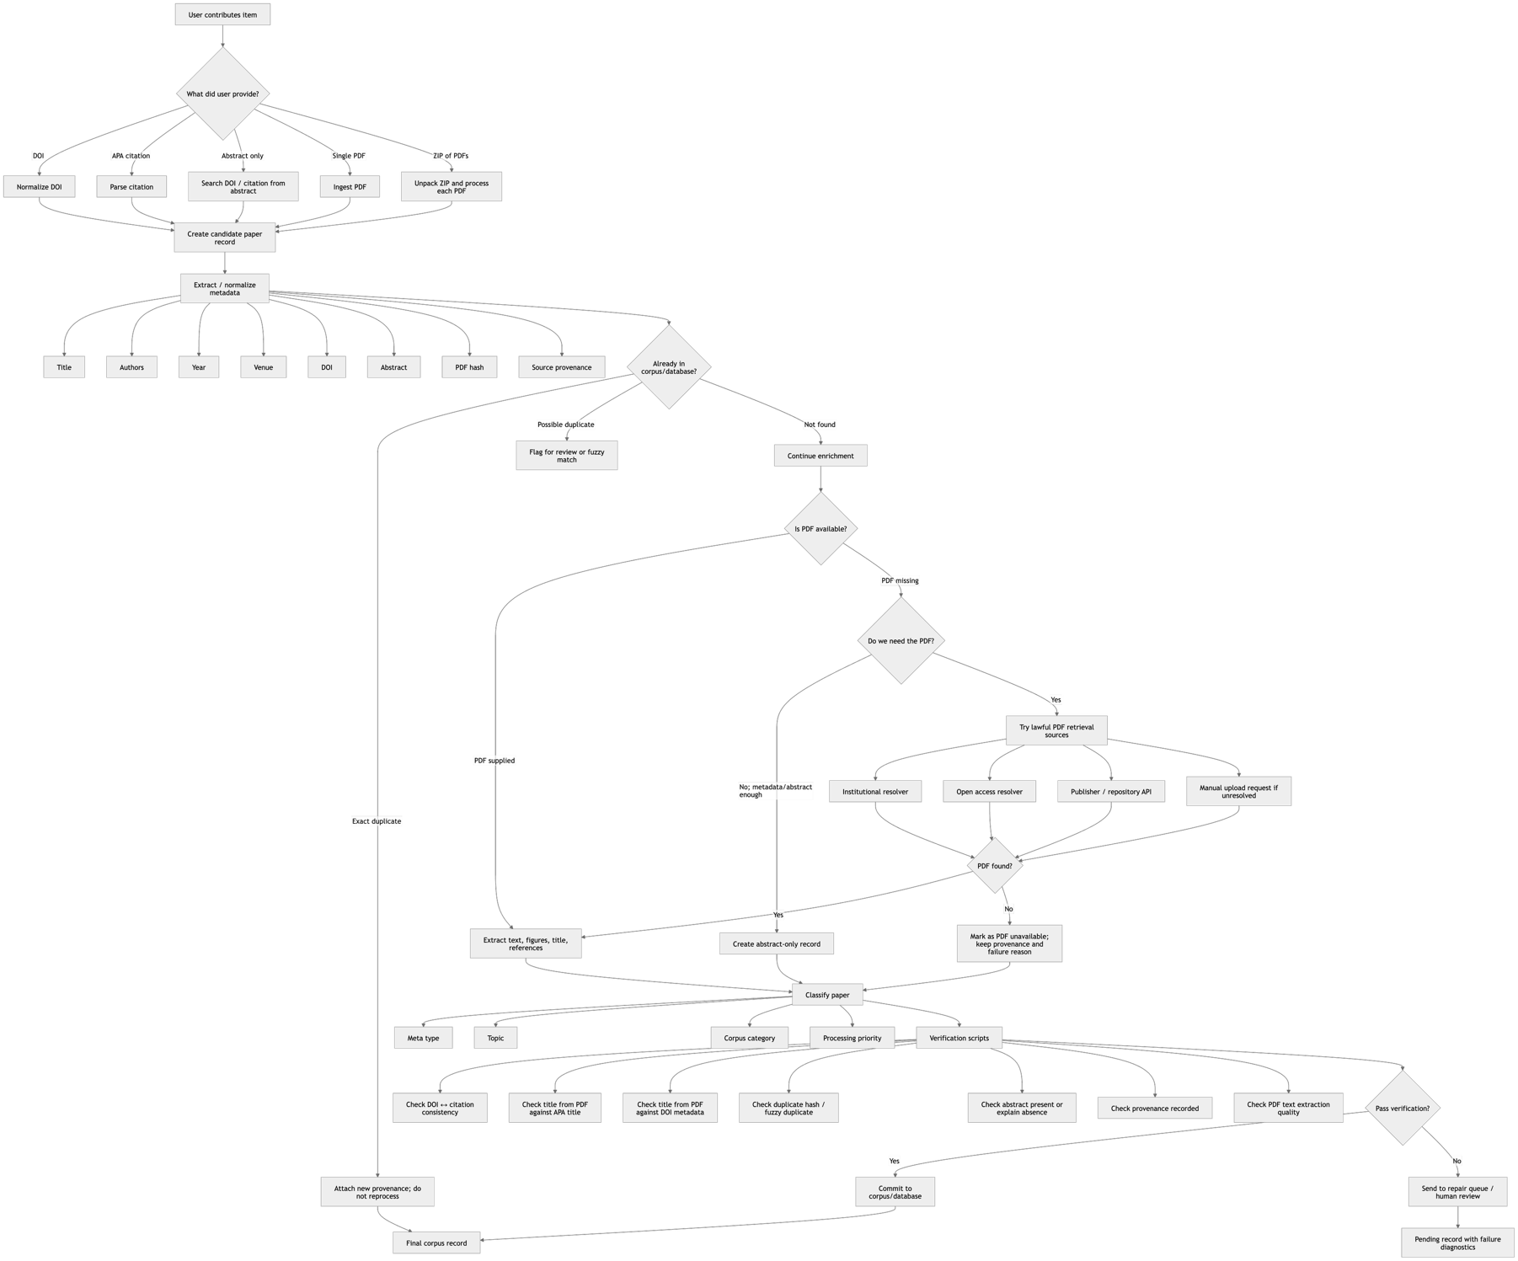

More formal visual specification

1. Contribution intake
The system accepts five input types:
Input type | Example | Minimum action
DOI | 10.xxxx/... | Resolve metadata, check corpus
APA citation | Author, year, title, venue | Parse, infer DOI, check corpus
Abstract | pasted abstract text | infer title/DOI/topic
PDF | uploaded single file | extract title/text/hash/metadata
ZIP | multiple PDFs | unpack and process each as PDF

2. Canonical paper record
Each contribution should be converted into a standard object:
{
"paper_id": "...",
"doi": "...",
"title": "...",
"authors": ["..."],
"year": "...",
"venue": "...",
"apa_citation": "...",
"abstract": "...",
"pdf_status": "present | missing | failed | not_required",
"pdf_hash": "...",
"source_provenance": [
{
"source_type": "user_upload | doi_lookup | open_access_api | library_resolver | manual",
"source_name": "...",
"timestamp": "...",
"success": true,
"notes": "..."
}
],
"meta_type": "empirical | review | theory | method | dataset | book_chapter | other",
"topic": "...",
"duplicate_status": "new | exact_duplicate | possible_duplicate",
"verification_status": "passed | failed | needs_review"
}

Success conditions
A contributed item counts as successfully processed when:
- It has a canonical paper record.
- It has either a DOI, a reliable citation, or a PDF-derived title.
- It has been checked against the existing corpus/database.
- Duplicate status is explicit.
- Provenance is recorded for every lookup, PDF, or metadata source.
- Meta type and topic have been assigned.
- Verification scripts have either passed or produced a clear failure reason.

Verification scripts implied by the board
The most important one appears to be:
Verify title from PDF with APA citation.
I would implement that as a title-consistency test:
Extract title from PDF first page
Compare against title parsed from APA citation
Compare against title resolved from DOI metadata
If similarity >= threshold: pass
If mismatch: flag for human review
Additional verification scripts:
verify_doi_format()
verify_apa_parse()
verify_pdf_readable()
verify_pdf_title_matches_citation()
verify_pdf_title_matches_doi_metadata()
verify_no_duplicate_pdf_hash()
verify_no_duplicate_doi()
verify_abstract_present_or_explained()
verify_provenance_complete()
verify_topic_and_meta_type_present()

Condensed implementation logic
FOR each contributed item:
1. Identify input type:
DOI, APA citation, abstract, PDF, or ZIP.
2. Normalize into candidate paper record.
3. Check corpus/database:
- DOI match
- title match
- PDF hash match
- fuzzy author/year/title match
4. If already present:
- add provenance
- avoid reprocessing unless new PDF or better metadata supplied.
5. If incomplete:
- resolve DOI if missing
- resolve abstract if missing
- retrieve PDF only when needed and lawful.
6. Process PDF if available:
- extract title
- extract text
- extract references
- compute hash
- capture provenance.
7. Classify:
- meta type
- topic
- corpus role.
8. Verify:
- title consistency
- citation consistency
- duplicate status
- provenance completeness.
9. Commit or send to repair queue.
The board is basically a good first architecture for an Article Eater / corpus contribution module: user contribution → metadata normalization → duplicate checking → PDF/abstract acquisition → type/topic classification → provenance recording → verification.

